Day 46 – MLOps Lifecycle

MLOps plays an important role in managing and scaling the deployment of machine learning models. It integrates machine learning workflows with practices where models are not only developed but also efficiently deployed and maintained. It fills the gap between model development and production.

MLOps Life Cycle

The MLOps life cycle involves several steps that guide the process from understanding a problem to deploying and monitoring a model.
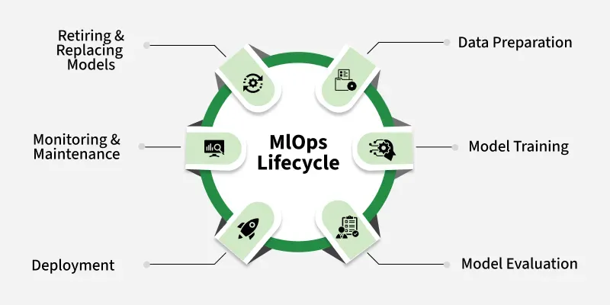
1. Problem Definition: The first step involves understanding the problem that needs to be solved using machine learning. This includes setting objectives and identifying key performance indicators (KPIs).
2. Data Collection and Preparation: In this we gather, clean and transform data. Data preparation is important as the quality of data directly impacts the performance of the model.
3. Model Development: Data scientists develop models using the prepared data and focus on algorithm selection, hyperparameter tuning and performance evaluation.
4. Model Deployment: After the model is trained and validated it is deployed into a production environment for real-time predictions.
5. Model Monitoring and Maintenance: After deployment continuous monitoring ensures that the model performs well in real-world scenarios. Monitoring includes tracking performance metrics and updating models as needed.

1. Development Phase
This is where data scientists and ML engineers build the model.

Activities

a) Data Collection
Gather data from databases, APIs, sensors, websites, etc.

b) Data Preparation
Clean and transform data.
We will do:
- Handling missing values
- Removing duplicates
- Feature engineering
- Encoding categorical variables

c) Model Training
Train machine learning algorithms on prepared data.
Example:
LinearRegression(), RandomForestRegressor(), XGBoost()

d) Model Evaluation
Check whether the model performs well.
Common metrics:
For Regression:
- MAE
- MSE
- RMSE
- R² Score
For Classification:
- Accuracy
- Precision
- Recall
- F1 Score

e) Model Versioning
Save different versions of models.
Benefits:
- Rollback to older versions
- Compare performance
- Track improvements

2. Deployment Phase
After training, the model is made available to users or applications.

Goal
To turn the model file into real-time prediction.

Deployment Flow
User
↓
Frontend
↓
API
↓
ML Model
↓
Prediction

Deployment Options

Local Deployment
Runs on your laptop.
Example:
uvicorn app:app --reload

Cloud Deployment
Runs on cloud servers.
Popular platforms:
- AWS
- Google Cloud
- Microsoft Azure

Container Deployment
Use Docker to package the application.
Benefits:
- Works anywhere
- Easy sharing
- Consistent environment

3. Monitoring Phase
Deployment is NOT the end.
Models can become inaccurate over time.
Monitoring ensures the model continues to perform well.

Why Monitoring is Needed?
Real-world data changes.
This is called Data Drift.

Example
Training Data:
Area: 1000-3000 sq ft
New Data:
Area: 5000-10000 sq ft
The model may start giving poor predictions.

Types of Monitoring

a) Data Monitoring
Checks:
- Missing values
- Unexpected inputs
- Feature distributions
Example:
Training Average Area = 1500
Current Average Area = 4000
Alert generated.

b) Performance Monitoring
Track model metrics.
Example:
Before Deployment:
RMSE = 25000
After Deployment:
RMSE = 90000
Performance has degraded.

c) System Monitoring
Monitor:
- CPU Usage
- Memory Usage
- Response Time
- API Failures
Example:
API Response Time > 5 seconds
Alert generated.

d) Prediction Monitoring
Track prediction outputs.
Example:
Normal Price Range:
5L – 50L
Model suddenly predicts:
5 Crore
Need investigation.

Retraining
When monitoring detects problems:
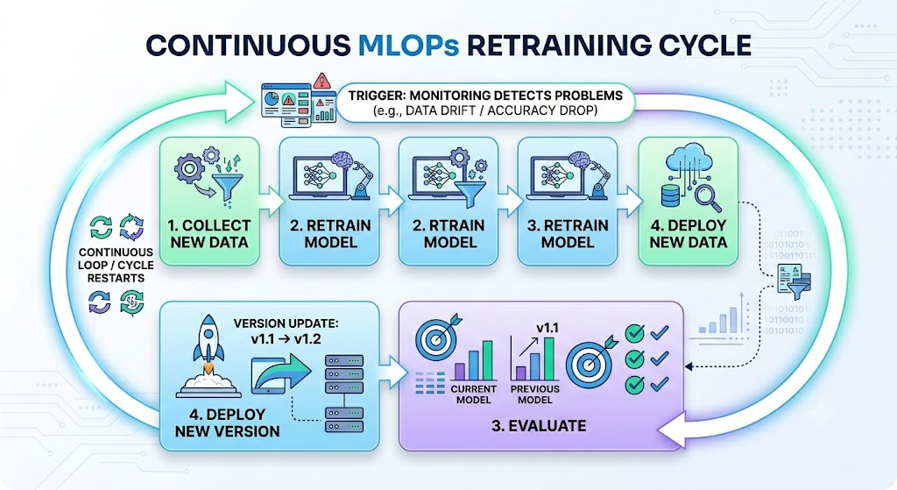
This creates a continuous cycle.

Complete MLOps Lifecycle :
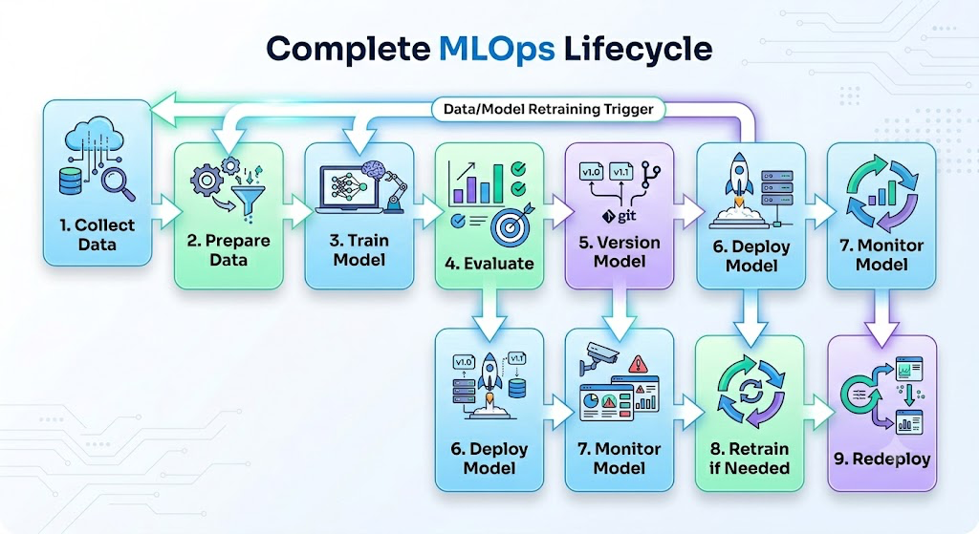

Real-World Example: House Price Prediction

Development
- Collect house data
- Clean data
- Train Random Forest Model
- Evaluate RMSE

Deployment
- Save model using Joblib
- Build FastAPI service
- Deploy to cloud

Monitoring
- Track prediction requests
- Monitor RMSE
- Detect data drift
- Retrain monthly with new house data

